

PROJECT 1”
“College Bus Route Tracking System : Route schedules + bus stop updates
Done by:
Name: Tejas Thoke
Srn No.: 31231168
A.Y. 2024-2025
Programme Name: BBA-CA
Course Name: Software Project Management
Couse Code: BBACA23605

Under The Supervision of Prof. Umesh Patwardhan sir
Department of Commerce and Management Faculty of Commerce and Management

PROJECT INTRODUCTION

The College Bus Route Tracking System is a digital solution designed to help students and college administration efficiently manage and track bus routes, schedules, and real-time bus stop updates. In many colleges, students face difficulties due to unclear bus timings, delays, and lack of proper communication regarding route changes or bus locations.
Traditional systems rely on printed schedules or verbal communication, which often leads to confusion, missed buses, and inconvenience for students. There is no centralized platform to track buses or receive updates about delays or route modifications.
To address this issue, the proposed system provides a web/mobile-based platform where students can view bus routes, schedules, and receive real-time updates about bus locations and stops. The system improves transportation efficiency, reduces waiting time, and enhances communication between students and transport management.
From a Software Project Management perspective, this project includes structured planning, system design, scheduling, risk management, and quality assurance, simulating real-world software development practices.

PROJECT CHARTER

To develop a centralized system that allows students to track college buses, view route schedules, and receive real-time updates about bus stops and delays.

Project Purpose

To develop a centralized digital platform that helps students manage study schedules, tasks, and reminders efficiently.

Problem Statement

Students face several issues:

Lack of real-time bus tracking

Uncertainty in bus arrival timings

Difficulty in identifying correct bus routes

No updates for delays or route changes

Dependence on static schedule

Proposed Solution

A system with features such as:

User login and profile system

Bus route and schedule display

Real-time bus tracking (GPS-based)

Bus stop notifications and updates

Delay alerts and route change notifications

Admin panel for route management

Stakeholders

Students (Primary Users)

Bus Drivers

Transport Department

College Administration

Project Manager

Assumptions

Students have smartphones with internet access

GPS tracking is available in buses

Users are willing to adopt the system

Constraints
- Limited development time (semester project)
- No budget for hardware implementation
- Academic-level implementation only

FEASIBILITY STUDY (TELOS FRAMEWORK)

Technical Feasibility

Technologies used:
  - Frontend: HTML, CSS, JavaScript
  - Backend: Node.js / PHP
  - Database: MySQL / MongoDB
  - Notification System: Email / Browser alerts
These technologies are widely supported and suitable for a student-level web application.

Economic Feasibility

  - Open-source tools used
  - No licensing cost
  - Free hosting options available
  - Development done in academic environment

Legal Feasibility

  - Stores only academic data (tasks, schedules)
  - Secure authentication implemented
  - No sensitive personal data misuse

Operational Feasibility

  - Simple UI for students
  - Easy task creation and tracking
  - Automated reminders improve usability
  - Reduces manual planning workload

Schedule Feasibility

  - Designed for semester timeline
  - Divided into phases (design, development, testing)
  - Achievable within academic deadline

4. SCOPE STATEMENT

The Scope Statement clearly defines the boundaries of the Task and Study Planner for Students project. It explains what functionalities are included in the system and what features are intentionally excluded to maintain focus, feasibility, and clarity within the academic project constraints.
In Scope
1. User Login System
- Students can register and log in securely

2. Bus Route Management
- Display all routes and stops
- Route-wise bus information

3. Route Schedules
- Bus timings for each route
- Daily schedule tracking

4. Real-Time Bus Tracking
- GPS-based location tracking
- Live bus movement display

5. Bus Stop Updates
- Notifications when bus reaches a stop
- Estimated arrival time

6. Notifications System
- Delay alerts
- Route change updates

7. Admin Panel
- Manage routes and schedules
- Update bus information

Out of Scope

The following features are intentionally excluded from the project:

1. Online Ticket Booking System
The system will not include any ticket booking or seat reservation functionality. The focus is only on tracking bus routes and providing schedule updates

2.Payment Gateway Integration
The platform will not support online payments, ticket fares, or financial transactions. It is strictly a tracking and information system.

3. Advanced AI-Based Route Optimization

Features such as AI-based route prediction, traffic analysis, or smart route optimization are not
Included.

4. Multi-Institution Integration

The system is designed for a single college only. It will not support multiple colleges, universities, or
inter-campus transportation systems.

5. Driver Performance Monitoring System

The system will not track driver behavior, attendance, or performance metrics. The focus remains on
route tracking and updates only.

6. Offline GPS Hardware Implementation

The project will not include actual hardware installation or real GPS devices in buses. GPS
functionality will be simulated or concept-based for academic purposes.

Scope Summary

The Task and Study Planner for Students is designed as a focused academic productivity tool that helps students manage their study schedules, tasks, and reminders efficiently. By limiting the system to personal academic planning only, the project ensures simplicity, usability, and successful implementation within the academic semester timeline.

5. SMART OBJECTIVES

The College Bus Route Tracking System is designed as a focused transportation management tool that helps students view bus routes, check schedules, and receive real-time updates about bus locations and stops.
By limiting the system to tracking, route schedules, and notification features only, the project ensures simplicity, usability, and successful implementation within the academic semester timeline. The system avoids complex functionalities like payments, AI optimization, or multi-institution integration to maintain feasibility and clarity.

Specific
The objective of this project is to design and develop a web-based College Bus Route Tracking System that allows students to view bus routes, check schedules, and receive real-time updates about bus locations and stops. The system aims to replace manual and static bus schedules with a centralized digital tracking solution.

Measurable

The success of the system will be evaluated based on:
• Accurate display of bus routes and stops
• Successful implementation of route schedules
• Proper functioning of real-time bus tracking (GPS/simulated)
• Timely notifications for bus arrivals and delays
• Reduction in student waiting time at bus stops
• System usability and error-free performance during testing
These metrics ensure that the system performance can be evaluated objectively.

Achievable

The project is realistically achievable within the academic constraints because:
- It uses simple and widely known technologies such as HTML, CSS, JavaScript, Node.js/PHP, and MySQL/MongoDB
- The features are limited to essential academic planning functions
- The development scope is manageable for a student-level project
- Open-source tools and frameworks reduce complexity and cost

Relevant

The project is realistically achievable within the academic constraints because:
• It uses simple and widely known technologies such as HTML, CSS, JavaScript, Node.js/PHP, and MySQL/MongoDB
• The features are limited to essential bus tracking and scheduling functions
• The development scope is manageable for a student-level project
• Open-source tools and frameworks reduce complexity and cost
- It aligns with real-world software development and project management practices
- It enhances practical knowledge of web development and system design

Time-Bound

The project will be completed within the duration of the academic semester. The timeline includes:
- Requirement analysis and planning phase
- Design and development phase
- Testing and debugging phase
- Final deployment and documentation phase
Each phase will be completed within predefined deadlines to ensure timely submission.

6. WORK BREAKDOWN STRUCTURE (WBS)

The Work Breakdown Structure (WBS) divides the project into smaller, manageable components.
This helps in better planning, task allocation, monitoring, and execution of the project.

Project Initiation Phase

This phase focuses on understanding the project requirements and defining the foundation of the
system.
1.1 Requirement Analysis
Identify user needs (students facing issues with bus timing and tracking)
• Define system requirements (routes, schedules, tracking, notifications)
• Study existing manual systems and their limitations
• Gather functional and non-functional requirements

1.2 Project Charter Preparation
Define project purpose and objectives
• Identify stakeholders (students, transport department, admin)
• Establish scope boundaries
• Document initial assumptions and constraints

1.3 Feasibility Study
Technical feasibility (technology selection and GPS integration)
• Economic feasibility (cost estimation using free tools)
• Operational feasibility (ease of use for students)
• Legal feasibility (data privacy and usage)
• Schedule feasibility (timeline analysis)

2. Planning & Design Phase
This phase focuses on system architecture, structure, and visual design.
2.1 UI/UX Design
Design user-friendly interface layouts
• Create login, dashboard, route view, and tracking pages
• Ensure simple navigation and accessibility
• Design mobile and desktop responsiveness

2.2 Database Design
Design tables for users, buses, routes, stops, and schedules
• Define relationships between entities
• Ensure data normalization
• Maintain data consistency and integrity

2.3 System Architecture
Define frontend and backend interaction
• Plan API structure for real-time tracking (if applicable)
• Decide data flow between modules
• Establish security and authentication flow

3. Development Phase
This is the core implementation phase of the project.
3.1 User Module (Login/Register)
User authentication system
• Secure login and registration
• Password protection and validation

3.2 Bus Route Management Module
Display available bus routes and stops
• Add, update, and manage route details
• Assign buses to routes

3.3 Bus Tracking Module
Implement GPS-based or simulated tracking
• Display real-time bus location on interface
• Update bus movement dynamically

3.4 Schedule Management Module
Define bus timings for each route
• Display daily schedule
• Allow schedule updates

3.5 Notification System
Generate alerts for bus arrival at stops
• Send delay notifications
• Provide route change updates

3.6 Dashboard Module
Display route summary and active buses
• Show current bus locations
• Provide quick access to all features

4. Testing Phase
Ensures the system is working correctly and efficiently.
4.1 Unit Testing
Test individual modules separately
• Verify login, route display, and tracking features

4.2 Integration Testing
Test interaction between modules
• Ensure smooth data flow between components

4.3 User Acceptance Testing (UAT)
Collect feedback from students
• Validate system usability
• Identify improvements

5. Deployment Phase
5.1 GitHub Upload
Upload complete source code
• Maintain version control
• Document repository properly

5.2 Hosting Setup
Deploy system on local or cloud server
• Configure database connection
• Ensure system accessibility

5.3 Final Deployment
Final testing after deployment
• Bug fixing and optimization
• System go-live

6. Project Closure Phase
6.1 Documentation
Prepare final project report
• Include diagrams and modules
• Ensure completeness of documentation

6.2 Final Review
Evaluate project against objectives
• Check system performance and stability
• Submit for academic evaluation

6.3 Lessons Learned
Analyze challenges faced
• Document improvements for future projects
• Reflect on technical and managerial learning

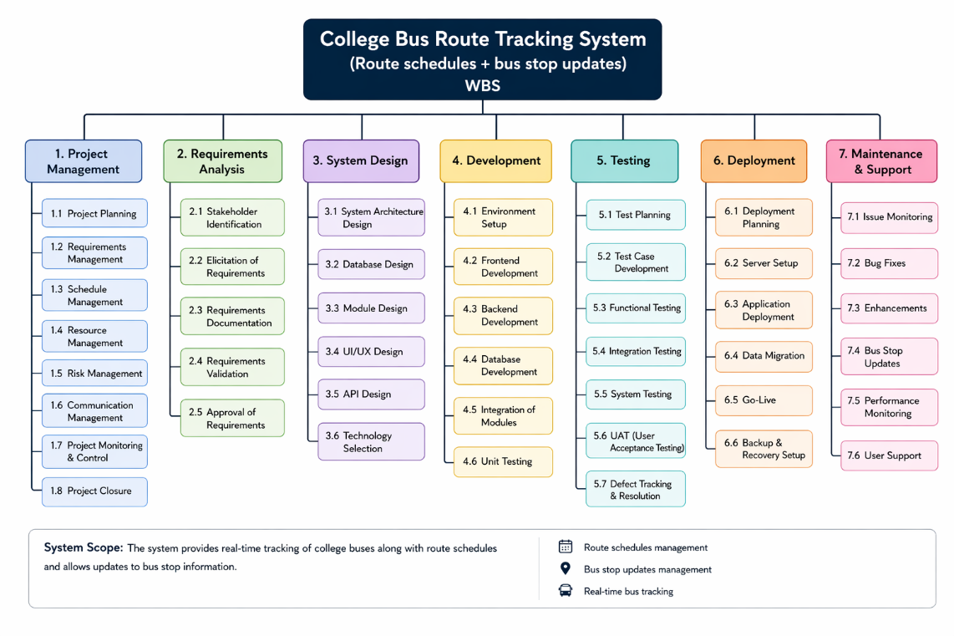

7.EFFORT AND COST ESTIMATION

Effort and cost estimation is an important part of Software Project Management as it helps in understanding the resources required for completing the project successfully within the given timeline. It also provides a structured approach to predict workload, development time, and resource utilization.

COCOMO Estimation (Basic Model)

The Basic COCOMO (Constructive Cost Model) is used to estimate effort based on the size of the software in Lines of Code (LOC).

Estimated Size

The Task and Study Planner system is estimated to require approximately:

4,000 to 5,000 Lines of Code (LOC)
This includes frontend design, backend logic, database integration, and notification system.

Effort Estimation

Using the Basic COCOMO model:
- Estimated Effort: 10 to 12 Person-Months
This means the project would require the equivalent effort of one person working for 10–12
months, or multiple team members working in parallel for a shorter duration.
Effort is distributed across phases such as:
- Requirement analysis and planning: Moderate effort
- UI/UX design: Moderate effort
- Backend and database development: High effort

- Testing and debugging: High effort
- Documentation: Moderate effort

Interpretation of Effort

- Development phase consumes the highest effort due to coding and integration complexity
- Testing phase requires significant effort to ensure system reliability
- Planning and documentation ensure structured execution but require comparatively less effort

Cost Estimation

Since this is an academic project, the cost is minimal and mostly theoretical.

Development Cost
  - No direct salary cost (student project)
  - No outsourcing or commercial development involved

Software and Tools Cost

  - HTML, CSS, JavaScript (Free)
  - Node.js / PHP (Open-source)
  - MySQL / MongoDB (Free versions available)
  - VS Code, GitHub (Free tools)

Hosting Cost
  - Optional hosting using free platforms such as:
    - GitHub Pages
    - Render / Netlify / Vercel (for frontend)
  - Minimal or zero cost for deployment

Operational Cost

  - Internet usage
  - System maintenance (negligible for academic scope)

STAKEHOLDER REGISTER

The Stakeholder Register identifies all individuals or groups involved in or affected by the project. Each stakeholder plays a specific role in ensuring project success.

1. Students (Primary Users)
Students are the main users of the system. They use the platform to:
• View bus routes and schedules
• Track real-time bus locations
• Receive notifications for bus arrivals and delays
• Plan travel based on bus timings
Their feedback is essential for improving system usability and accuracy.

2. Transport Department / Bus Management
The transport department manages the bus operations. Their responsibilities include:
• Managing bus routes and schedules
• Updating route changes and timings
• Monitoring bus movement and availability
• Ensuring accurate information is provided in the system

3. Faculty Members (Supervisors)
Faculty members act as academic guides. Their responsibilities include:
• Monitoring project progress
• Providing feedback and suggestions
• Evaluating system functionality
• Ensuring academic alignment

4. Institution (Management)
The institution acts as the project sponsor and supports:
• Approval of project topic
• Academic supervision
• Evaluation and grading

5. Developers
Developers are responsible for:
• Designing system architecture
• Writing and testing code
• Implementing bus tracking and notification features
• Fixing bugs and ensuring system performance

6. Project Manager
The project manager ensures smooth execution by:
• Coordinating tasks among team members
• Managing deadlines and schedules
• Monitoring progress using WBS
• Handling risk and communication

Stakeholder | Role/Type | Interest in Project | Influence | Responsibility
Students | Primary Users | Use system for tracking buses & schedules | High | Provide feedback, use system
Transport Department | Supervisor | Monitor progress &  guide | Medium | Review project, give suggestions
Faculty Members | Sponsor | Academic  evaluation | High | Approve &  evaluate project
Institutio | Management | Ensure  project success | High | Planning,  scheduling, coordination
Developers | Technical Team | Build the  system | High | Coding, testing,  implementation

- RACI MATRIX: The RACI Matrix defines roles and responsibilities in the project clearly.

R – Responsible: Developers are responsible for actual system development, coding, testing, and implementation of features such as tasks, timetable, and reminders.

A – Accountable: The Project Manager is accountable for the overall success of the project and ensures that all tasks are completed on time and meet requirements.

C – Consulted: Faculty Supervisor provides expert guidance, reviews project progress, and suggests improvements during development.

I – Informed: Students and Institution are kept informed about project progress, updates, and final outcomes.

Task/Activity | Responsible (R) | Accountable (A) | Consulted (C) | Informed (I)
Requirement  Analysis | Developer | Project Manager | Faculty | Institution
Design Phase | Developer | Project Manager | Faculty | Students
Development | Developer | Project Manager | Faculty | Students
Testing | Developer | Project Manager | Faculty | Institution
Deployment | Developer | Project Manager | Faculty | Institution
Documentation | Team | Project Manager | Faculty | Institutio006E

COMMUNICATION PLAN

Effective communication ensures smooth collaboration among all stakeholders and helps avoid misunderstandings during development.

Communication Objectives

- Ensure timely sharing of project updates
- Improve coordination between team members
- Provide clarity in task execution
- Support decision-making through regular feedback
- Maintain transparency throughout the project

Communication Methods

- Weekly Progress Updates

  - Summary of completed tasks
  - Pending work and next steps
  - Issues faced during development

Faculty Meetings

  - Conducted every 1–2 weeks
  - Review project progress
  - Receive academic guidance

Developer Coordination

  - Daily or as-needed communication
  - Resolve technical issues
  - Assign tasks and track progress

Email Communication

  - Formal communication channel
  - Submission of reports and documentation
  - Official approvals

WhatsApp / Chat Tools
  - Quick updates
  - Instant problem-solving discussions
  - Informal coordination

Reports

  - Monthly or milestone-based reports
  - Document project progress
  - Used for evaluation purposes

Communication Frequency

  - Weekly: Progress tracking
  - Bi-weekly: Faculty reviews
  - Daily: Development discussions (if needed)

  - Milestones: Formal reporting

Communication Type | Purpose | Medium/Tool | Frequency | Participants
Weekly Progress Report | Track progress | Report / Docs | Weekly | Team, Project Manager
Faculty Meeting | Guidance & review | Meeting / Online | Bi-weekly | Team, Faculty
Team Discussion | Task  coordination | WhatsApp /  Chat | Daily | Developers
Email Updates | Formal communication | Email | As needed | All stakeholders
Project Reports | Document  milestones | Documents | Monthly | Institution, Faculty

RISK MANAGEMENT

Risk management ensures that potential problems are identified early and controlled effectively to
avoid project delays or failures.

Risk Identification

- Requirement Changes

  - Stakeholders may change requirements during development
  - Can lead to redesign or rework

Development Delays

  - Coding issues or time constraints may slow progress
  - Poor estimation may affect deadlines

Notification System Failure

  - Reminder system may not function properly
  - Could affect system reliability

User Resistance

  - Users may prefer traditional methods
  - Low adoption of system

Risk Mitigation Strategies

- Proper Documentation

  - Clear requirement documentation avoids confusion
  - Reduces unnecessary changes during development

Agile Task Breakdown

  - Using WBS to divide tasks into smaller units
  - Ensures better tracking and control

Regular Testing

  - Continuous testing helps detect bugs early
  - Improves system stability

Simple UI Design

  - Easy-to-use interface encourages adoption
  - Reduces learning curve for users

Feedback Collection

  - User feedback helps improve system usability
  - Ensures system meets real needs

Risk ID | Risk  Description | Impact | Probability | Mitigation  Strategy
R1 | Requirement changes | High | Medium | Proper documentation & approval  process
R2 | Development  delays | High | Medium | Use WBS and  proper  scheduling
R3 | Reminder  system failure | Medium | Low | Regular testing  & debugging
R4 | Technical issues/bugs | High | Medium | Continuous testing & code  review
R5 | User resistance | Medium | Low | Simple UI and  user-friendly design

QUALITY ASSURANCE PLAN

The Quality Assurance Plan ensures that the system meets required standards of functionality, reliability, and usability.

Quality Activities

- Code Reviews

  - Reviewing code for errors and improvements
  - Ensures coding standards are followed

Functional Testing

  - Testing each feature individually
  - Ensures correct system behavior

Integration Testing

  - Checking interaction between modules
  - Ensures smooth data flow

User Acceptance Testing

  - Final testing by end users
  - Ensures system meets expectations

Bug Tracking System

  - Recording and resolving system issues
  - Ensures continuous improvement

Performance Monitoring

  - Checking system speed and efficiency
  - Ensuring smooth operation under load

Success Criteria

The project is considered successful if:
  - Tasks are tracked accurately
  - Reminders work reliably
  - System is easy to use
  - No major functional errors exist
  - Users are satisfied with performance

CONFIGURATION MANAGEMENT

Configuration Management ensures proper control and tracking of all changes made during the
project lifecycle.

Version Control System

- GitHub is used for maintaining project code
- All changes are tracked through commits
- Version history is maintained for rollback if needed

Change Tracking

- Every update is documented
- Changes are reviewed before implementation
- Ensures system stability and consistency

Backup and Recovery

- Regular backups of project files
- Ability to restore previous versions
- Prevents data loss during development

Release Management

- Controlled deployment of system versions

- Testing before final release
- Ensures stable production version

Benefits

- Maintains project consistency
- Improves collaboration
- Reduces errors and conflicts
- Ensures smooth development lifecycle

SYSTEM DESIGN

ER Diagram

The system includes the following entities:
    - Students
    - Tasks
    - Subjects
    - Timetable
    - Reminders Relationships:
    - One student can have multiple tasks
    - Each task belongs to a subject
    - Timetable is linked to student schedule
    - Reminders are associated with tasks and deadlines

DFD (Data Flow Diagram)

Level 0

    - Student interacts with system
    - System processes tasks, timetable, and reminders
    - Output is progress tracking and notifications

Level 1

    - Input: Task creation, timetable entry
    - Process: Data validation, scheduling, reminder generation
    - Output: Dashboard updates and notifications

12. UI MOCKUPS

- Dashboard

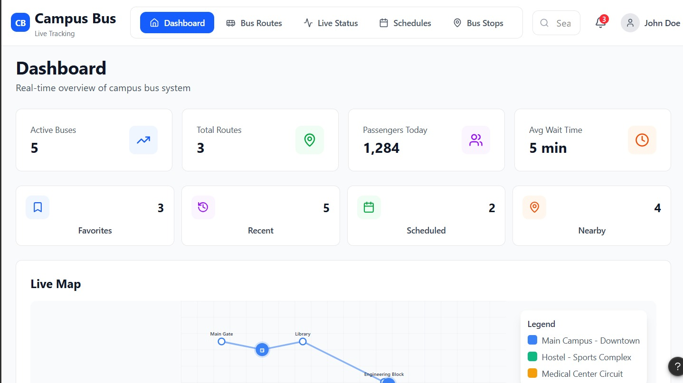

- Bus Route

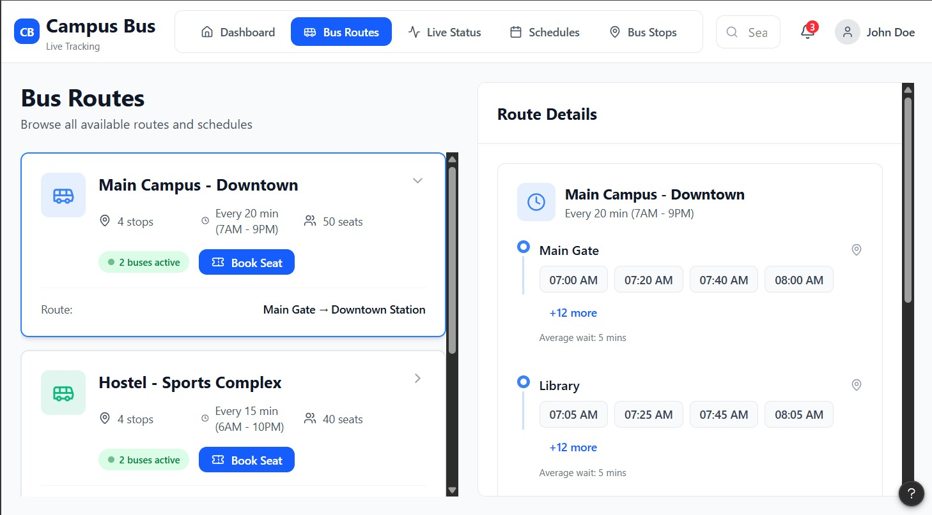
3.Live Status

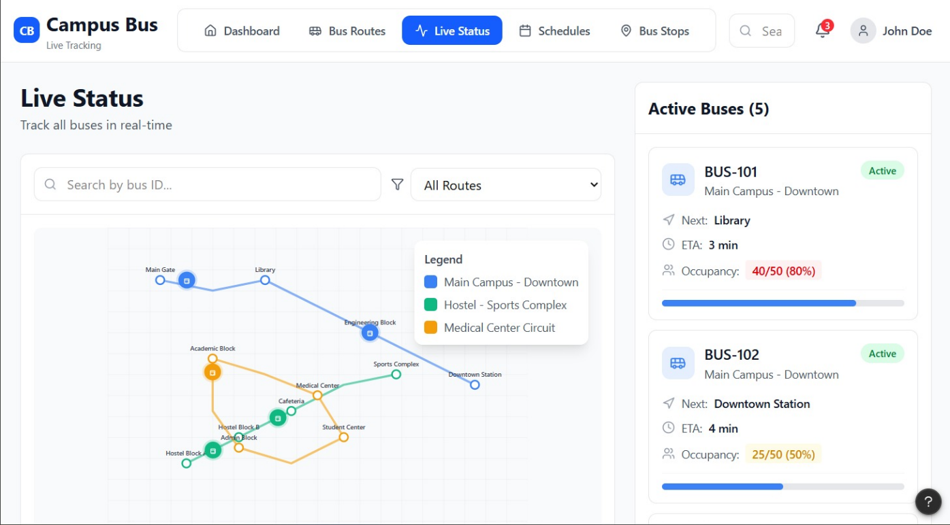
4.Schedules

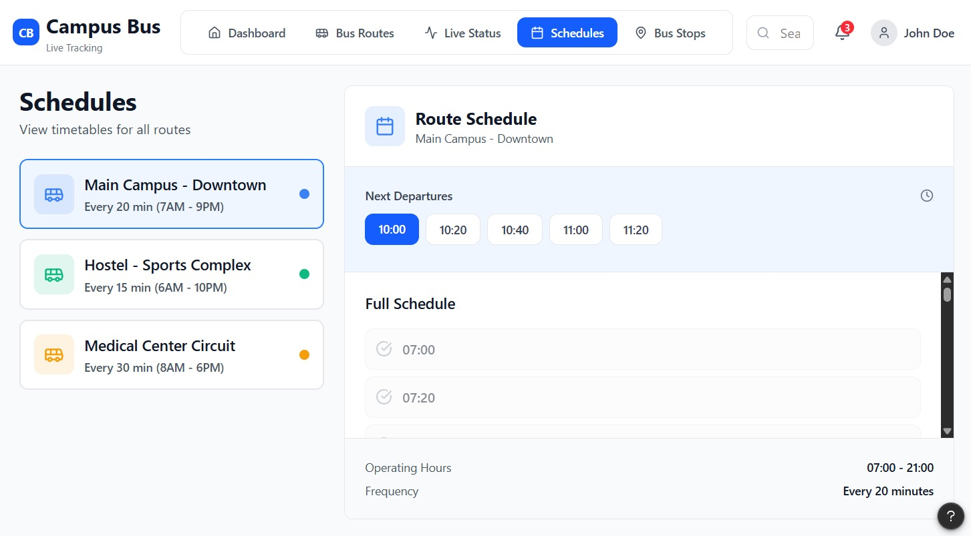

5. Bus Stope

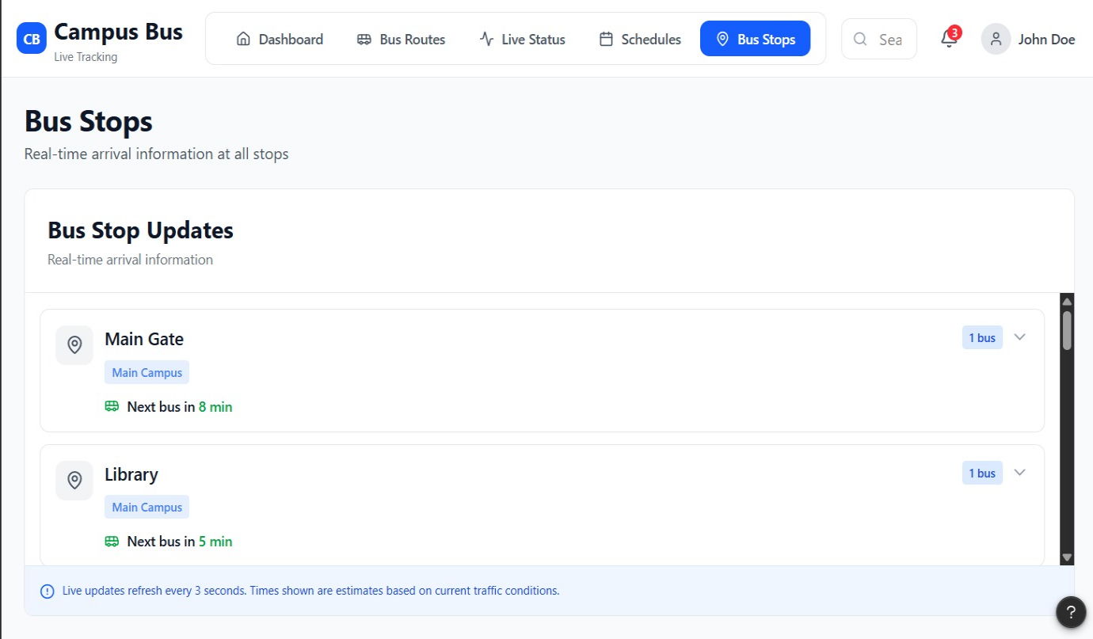

WEEKLY PROJECT STATUS REPORT

The Weekly Project Status Report tracks progress throughout development.
Each week includes:
- Completed tasks
- Issues faced
- Pending work
- Next week planning Example:
- Week 1: Requirement analysis completed
- Week 2: UI design completed
- Week 3: Backend development started
- Week 4: Testing phase initiated
This ensures transparency and timely completion of the project.

PROJECT CLOSURE AND LESSONS LEARNED

Project Closure

The Task and Study Planner for Students project was successfully completed within the academic timeline. All planned modules including task management, timetable generation, reminder system, and dashboard functionality were implemented and tested successfully.
All documentation such as Project Charter, WBS, Risk Management Plan, Quality Assurance Plan, and System Design diagrams were completed in detail. The system meets all defined objectives and successfully addresses the problem of poor student time management.The final product demonstrates proper implementation of Software Project Management principles, structured development methodology, and real-world application of web technologies. The project is now ready for academic evaluation.

Lessons Learned

This project provided valuable learning experiences in both technical and managerial aspects of software development.

Key Learnings:

    - Importance of structured planning before development
    - Effective use of Work Breakdown Structure (WBS) for task division
    - Understanding of effort and cost estimation using COCOMO model
    - Importance of risk identification and mitigation strategies
    - Practical experience with GitHub version control and collaboration
    - Importance of UI/UX design for user engagement and usability
    - Real-world understanding of software project lifecyc

